Antarctic Ice Sheet: past and present

An educational module for high-school and introductory-college students focused on changes in the Antarctic Ice Sheet from 20,000 years ago to present.
Developed by Leigh Stearns (University of Kansas; stearns@ku.edu) and Lauren Simkins (University of Virginia; lsimkins@virginia.edu) as part of NSF Office of Polar Programs Grant 1745055.

The continent of Antarctica is larger than the United States and Mexico combined and is home to the largest block of ice on Earth, the Antarctic Ice Sheet, that has formed as snow accumulated over millions of years as glaciers have merged together and swamped the land. The ice sheet is up to 4,800 meters thick and flows like a slow-moving river across the land and, in many places, directly into the surrounding ocean causing sea-level rise. The future of the ice sheet in a warming world is a huge unknown and poses challenges for estimating the rise in sea level in the coming decades and centuries.

Before you begin the interactive lesson in class, you will be asked to complete this pre-lesson assignment that will get you thinking about the Antarctic Ice Sheet and give you environmental and geospatial context for the activities you will complete during the lesson.

Getting started
You will need an internet connection on a cell phone, tablet or computer to complete the pre-lesson assignment, but preferably a tablet or computer.

Part 1: What and where is Antarctica?
Question 1.1. Watch this 5-minute National Geographic video: https://www.youtube.com/watch?v=WqnQo3DgEoo. What makes Antarctica a unique continent? To what conditions have animals adapted in order to thrive in Antarctica and the surrounding ocean?

Question 1.2. If the climate and precipitation conditions are right for the accumulation of snow over thousands of years, glacial ice can grow and persist. This glacial ice can eventually form mountain glaciers, ice caps, and continent-scale ice sheets. The definition of glacial ice is a mass of ice formed by compaction and recrystallization of snow, lying largely or entirely on land and showing evidence of past or present movement. Why does glacial ice move and what conditions could cause ice flow across the land to speed up? You can use these two readings to help in answering the question: “Ice, Snow, and Glaciers and the Water Cycle” (https://www.usgs.gov/special-topic/water-science-school/science/ice-snow-and-glaciers-and-water-cycle?_ga=2.206125331.1271516104.1624377227-1176360496.1612535566&qt-science_center_objects=0#qt-science_center_objects) and about stress and strain in glacial ice
(http://www.antarcticglaciers.org/glacier-processes/glacier-flow-2/glacier-flow-ii-stress-and-strain/).

Part 2: The geography of Antarctica
Question 2.1. Go to the online version of Google Earth (https://earth.google.com/web/) and zoom in so that Antarctica is in the center of your screen. Find the vertical toolbar on the left side of the screen and click on the “measure distance and area” tool (). How far is the nearest land in Antarctica from the southern tip of Chile, South America and Tasmania, an island state of Australia in kilometers (km) rounded to the nearest hundred kilometers? What influence might the ocean surrounding the continent have on climate in Antarctica?
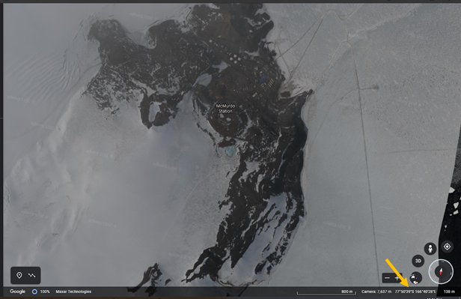
Question 2.2. Where do you see land that is not entirely covered by ice? Take screenshots of two locations where you can see land and paste them here. Indicate the approximate latitude and longitude of the locations by moving the cursor somewhere over the visible land and noting the latitude and longitude in the bottom right corner of the window (see image to the right).
- Make 2 observations of the land you see in each location.
- What parts of the cryosphere (if any) are in your screenshots? Read this for a description of all parts of the cryosphere: https://nsidc.org/cryosphere/allaboutcryosphere.html

Question 2.3. Just because you can’t see it, the land exists beneath the massive Antarctica Ice Sheet. This means that the ice sheet is resting on and moving across the land that is in some places beneath 4 kilometers of ice! Pick an item with a definable length - like the Space Needle in Seattle, Washington or a type of cell phone:
- What is the item you choose and what is its length in km?
- How many of that item you choose will have to stack up to equal 4 km of ice?

Answer here if you are completing the pre-lesson assignment by computer.

Question 1.1. [Answer here]
Question 1.2. [Answer here]
Question 2.1. [Answer here]
Question 2.2. [Answer here]
Question 2.3. [Answer here]

